**Summary Table (Station ID, Province, BFI, Latitude, Longitude)**

**Geographical Map with Baseflow Indices**

[**https://public.tableau.com/app/profile/benedictus.harley.kartawidjaja/viz/HydrometricGeographicalMapof20StationsBCandON/Sheet1?publish=yes**](https://public.tableau.com/app/profile/benedictus.harley.kartawidjaja/viz/HydrometricGeographicalMapof20StationsBCandON/Sheet1?publish=yes)

**Discussions**

**Spatial pattern of baseflow index**

The observed discrepancy in mean Baseflow Index (BFI) values between Ontario and British Columbia (BC), based on the average of 10 sample stations in each region, aligns with the influence of various physio-climatic factors. In Ontario, characterized by a higher BFI of 0.8734, several factors contribute to elevated baseflow. The province's diverse precipitation patterns, featuring consistent rainfall and potential for snowmelt, support substantial groundwater recharge, resulting in a larger contribution of baseflow to streamflow. Additionally, Ontario's favorable geological features, such as permeable aquifers and conducive rock types, facilitate efficient groundwater storage and movement, further enhancing baseflow.

Conversely, British Columbia's lower mean BFI of 0.7908, based on the average of 10 sample stations, is indicative of a relatively smaller contribution of baseflow to total streamflow. This is influenced by BC's diverse climatic conditions, including less consistent precipitation, which limits groundwater recharge. The province's intricate topography, variations in elevation, and land cover characteristics, such as forests and vegetation, also play roles in the observed spatial pattern of baseflow indices. The contrasting BFI values underscore the importance of considering the nuanced interplay of physio-climatic factors, including precipitation, temperature, snowmelt, geology, elevation, and land cover, in understanding the hydrological dynamics across these regions.

**Plot Streamflow & Baseflow (m^3/ s) vs Time**

1. A graph of a graph with blue and orange lines

   Description automatically generated
2. **A graph of a graph

   Description automatically generated with medium confidence**
3. 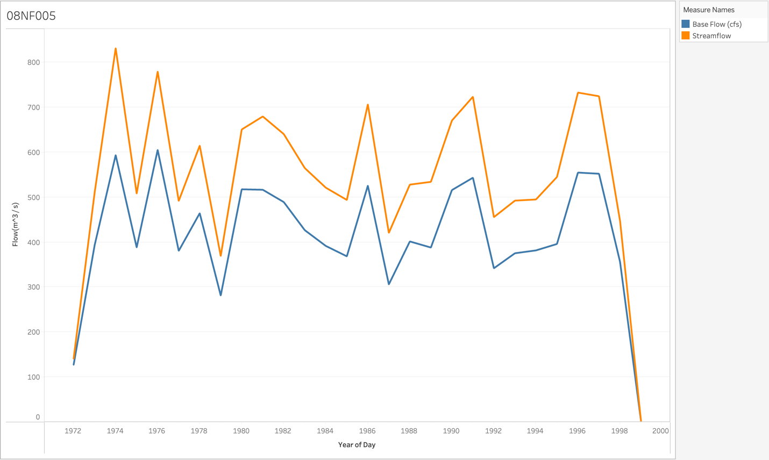
4. 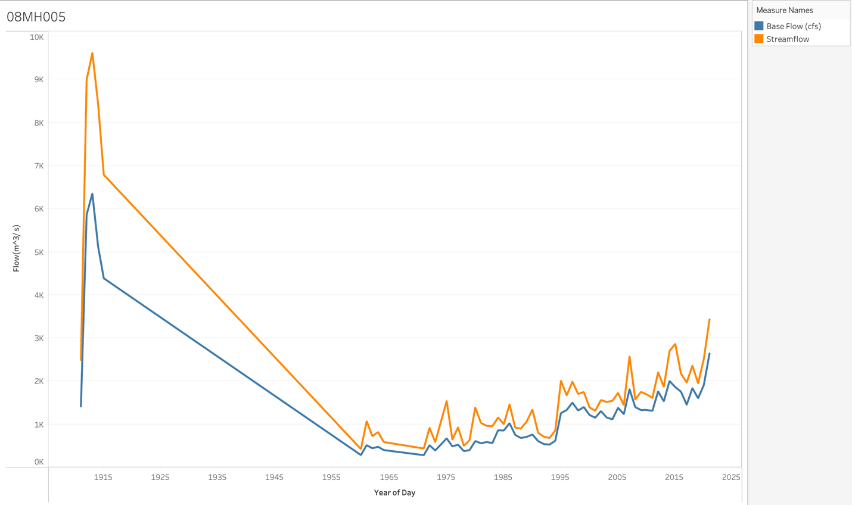
5. 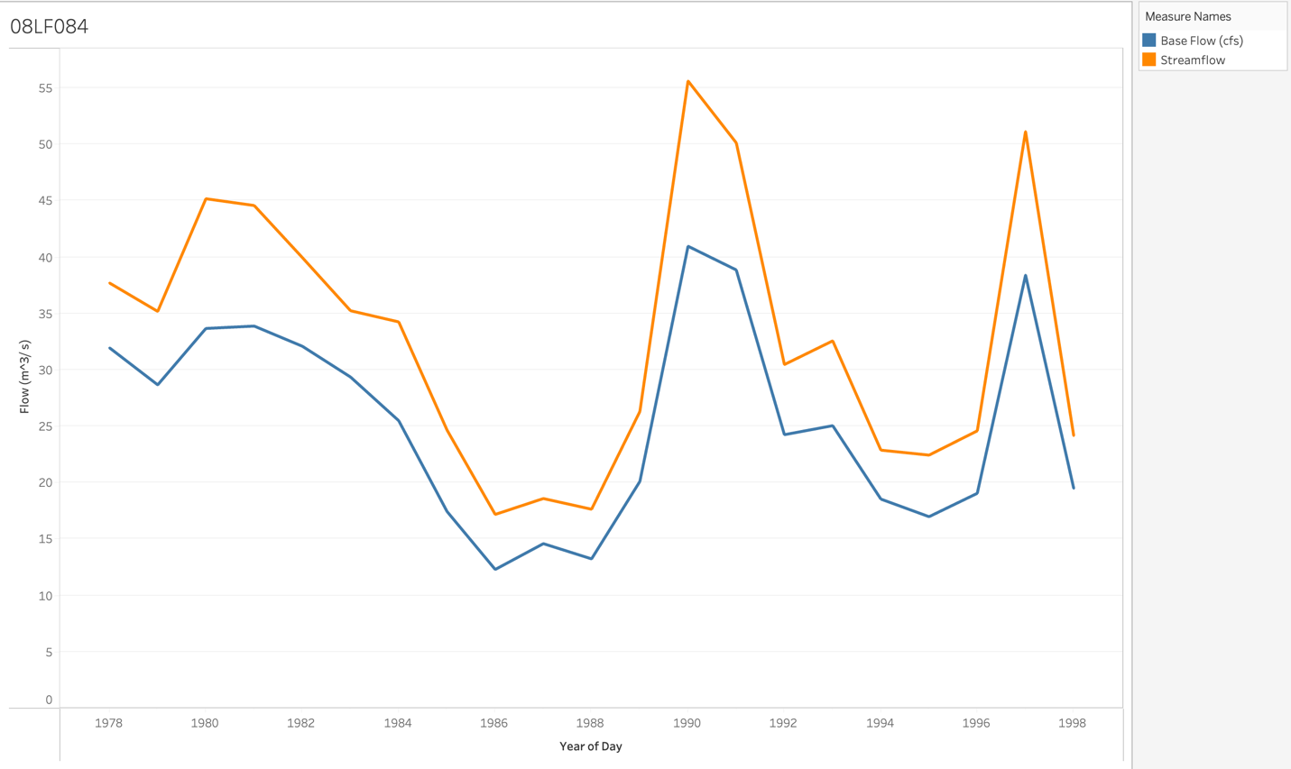
6. A graph showing a line of a graph

   Description automatically generated with medium confidence
7. **A graph showing the growth of a stock market

   Description automatically generated with medium confidence**
8. **A graph showing the growth of a number of people

   Description automatically generated with medium confidence**
9. **A graph of a graph

   Description automatically generated with medium confidence**
10. **A graph showing the growth of a stock market

    Description automatically generated with medium confidence**
11. **A graph showing the growth of a stock market

    Description automatically generated**
12. **A graph showing the growth of a stock market

    Description automatically generated with medium confidence**
13. **A graph showing the growth of a stock market

    Description automatically generated**
14. **A graph with orange and blue lines

    Description automatically generated**
15. **A graph showing the growth of a stock market

    Description automatically generated with medium confidence**
16. **A graph with blue and orange lines

    Description automatically generated**
17. **A graph showing a line of blue and orange lines

    Description automatically generated**
18. **A graph with blue and orange lines

    Description automatically generated**
19. **A graph of blue and orange lines

    Description automatically generated**
20. **A graph of blue and orange lines

    Description automatically generated**